Functional Requirement:

1) Start the game

2) Enters name

3) Place X and O

4) Reset the game

5) Start new game

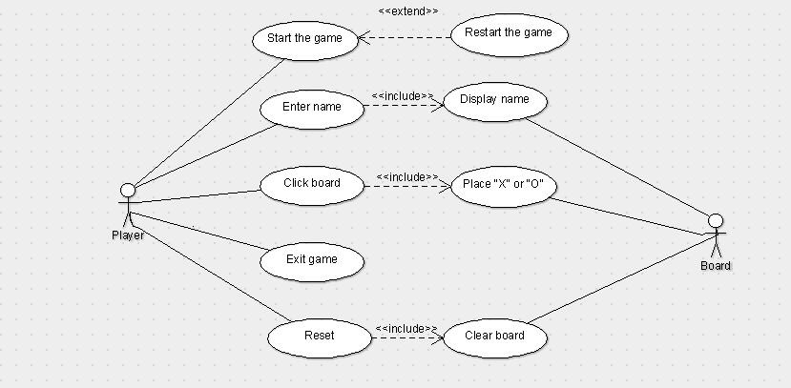

**Deliverable 1:**

Use case 1:

1) Start a game

Main Actor: Player

User clicks on the start button and system starts the game, while user plays the game, system will display the player information to the user. If there is an error displayed while starting the game then the user will acknowledge the error and restart the game again.

2) Reset the game

Main Actor: Player

Secondary Actor: Game Board

User will start the game and system will display the game board to the user. When user clicks on the reset button the game board will reset and the game will be started again. If there was a resumed game then after doing the reset the game will be started from beginning.

3) Exit the game

Main Actor: Player

User will click on the start button to start the game, system will start the game. Then, User click on the exit button and system will close the game board.

|  |  |
| --- | --- |
| Use Case ID | UC1 |
| Use Case Name | Start a game |
| Primary Actor | Tic Tac Toe Player |
| Secondary Actor | Game Board |
| Pre Conditions | Game should be downloaded in the system |
| Success Guarantee (Postconditions) | Player should be able to start the game |
| Main Success Scenario | 1. The user click on start button  2. System will start the game |
| Extensions (Alternative Scenario) | 2a. At any point of time if there is an error displayed, then user should be able to change the parameters. |